**Step 1: Connect to Azure Cloud Shell**

1. Go to the [Azure Portal](https://portal.azure.com).

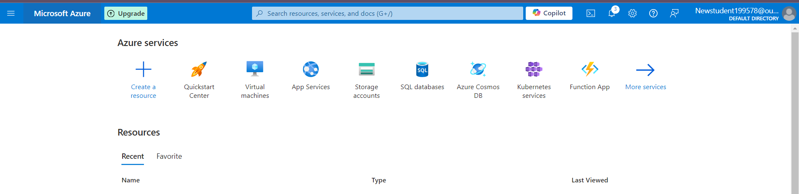

1. Click on the **Cloud Shell** icon (a terminal icon) at the top-right corner of the portal.

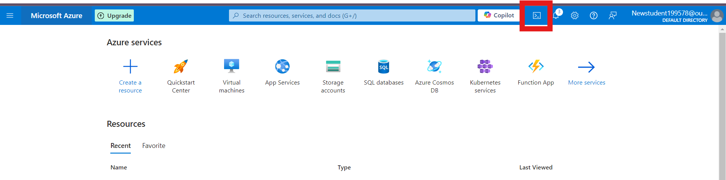

1. Select **PowerShell**.



1. The Cloud Shell will automatically connect to your Azure environment.

**Step 2: Create a Resource Group**

Once inside Cloud Shell:

**PowerShell:**

1. Run the following command to create the resource group:

**New-AzResourceGroup -Name "rg-1" -Location "South Central US"**

**New-AzResourceGroup -Name "rg-2" -Location "South Central US"**

1. Run the following command to create the storage Account:

**az storage account create --name shahid199578 --resource-group rg-1 --location eastus --sku Standard_LRS**

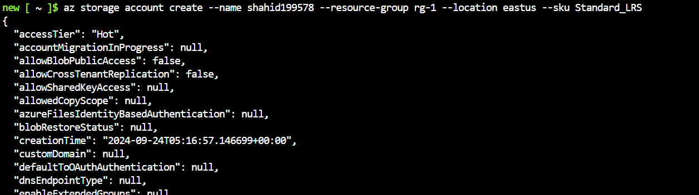

1. Run the following command to show the storage Account:

**Get-AzStorageAccount -ResourceGroupName "rg-1"**



1. Run the following command to move the storage Account:

**az resource move --destination-group rg-2 --ids $(az storage account show --name shahid199578 --resource-group rg-1 --query id -o tsv)**

1. Run the following command to show the storage Account:

**az storage account list --resource-group rg-2 --output table**

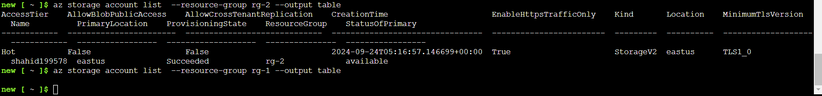

**az storage account list --output table**

